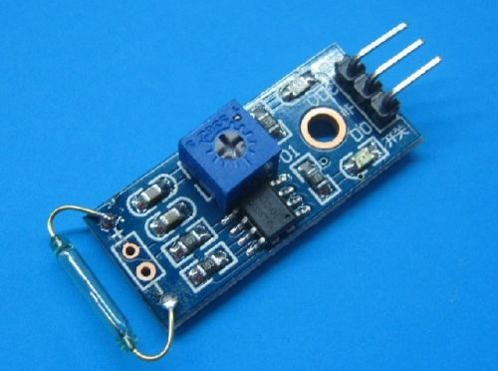

**Specification**

1, The use of imported normally open dry Reed tube

2, Comparator output signal clean wave well, driving ability, than 15mA.

3, Rated voltage and 3.3V-5V

4, Outputs: digital switching output (0 and 1)

5, Abolt-hole, is easy to install

6, Small Board PCB dimensions: 3.2cm x 1.4cm

7, Using wide LM393 voltage comparator

**Description:**

1. The Reed switch and magnet fit is required, at the time of induction to a certain degree of magnetic, on-State, the module output low level, when there is no magnetic force, a

disconnected state, output high, Reed switch and magnets sensing distance of the 1.5cm beyond insensitive or will not trigger the phenomenon;

2. DO the module output can be directly connected to the microcontroller I/O ports, Reed can be detected by single-chip microcomputer trigger status;

3. Modules DO the output connected to the relay IN-formed power Reed switch, direct control of high voltage.

May 8, 2014

**Magnetic Reed Switch & Water Sensor** - These two devices work the same way, they are (for the most part) switches, what I found interesting and was not expecting is that both are active low devices, What that means, is they both pass the 3.3v or 5v until the either a magnetic is put to the reed switch, or the contacts on the water sensor are connected, then they go low.

There are probably a dozen of ways to use these, I ended up hooking them to an analog in and reading the voltages from there output lines, and then I turned on the LED connected to pin 13.

<http://arduino.cc/en/Tutorial/ReadAnalogVoltage>

My slightly modified sketch:

/*

ReadAnalogVoltage

Reads an analog input on pin 0, converts it to voltage, and prints the result to the serial monitor.

Attach the center pin of a potentiometer to pin A0, and the outside pins to +5V and ground.

This example code is in the public domain.

*/

// the setup routine runs once when you press reset:

void setup() {

// initialize serial communication at 9600 bits per second:

Serial.begin(9600);

pinMode(13, OUTPUT);

}

// the loop routine runs over and over again forever:

void loop() {

// read the input on analog pin 0:

int sensorValue = analogRead(A0);

// Convert the analog reading (which goes from 0 - 1023) to a voltage (0 - 5V):

float voltage = sensorValue * (5.0 / 1023.0);

// print out the value you read:

Serial.println(voltage);

if (voltage > 1) {digitalWrite(13, LOW);}

if (voltage < 1) {digitalWrite(13, HIGH);}

}

I never saw these ever make it clear to zero volts, but I don’t know what kind of resolution the A2D converter has, and it doesn’t really matter. I made a choice that anything under 1 volt was going to turn something on, and any thing above 1 volt was going to turn that off.

Like I said there are probably a dozen of different ways to use these, that just seemed to be the quickest way.

